Machete Operations and Maintenance

V1.1

Manager Overview (Araceli) 3

The most important reports 3

1. Weekly work order status (Pie Charts) 3

2. Monthly work order status (Pie Charts) 4

Manager Questions 4

3. Worker Signins with Expired Memberships (List) 4

Manager Questions 4

Operations Tasks (Dispatchers – Juan and Gabriel) 5

Daily operations tasks 5

1. Review Machete Work Order Summary 5

Dispatcher questions 6

1.1 Were all work orders assigned a worker and completed? Or alternatively, was the work order cancelled? 6

1.2 Are there any work orders in the past that are still active or pending? 6

2. Review Machete Work Orders by color 6

A bigger example 7

Dispatcher Questions 7

3.1 Can the worker for the orange work order be found? If so, update Machete 7

3.2 Is the blue or grey order in the past? Do we have a paper record? Can we update Machete? 7

Weekly operations tasks 8

3. Review Monthly Work Order Statuses (pie charts) 8

Dispatcher Questions 8

4.1 Are the percentages of incomplete work orders shrinking? 8

4.2 Are there work orders in the past that are not completed or cancelled? 8

4. Review Incomplete Work Orders (List) 8

Dispatcher Questions 9

5.1 Can we find which worker was assigned for a given incomplete work order? 9

5.2 Are the total numbers of incomplete work orders shrinking over time? 9

5.3 What can be done so that there are no incomplete orders in the coming month? 9

5. Review Workers-Signins Past Membership Expiration 10

Dispatcher Questions 10

6.1 Are the worker records current? 10

6.2 Do they reflect all renewed memberships? 10

# Manager Overview (Araceli)

Machete records worker registrations, work orders, and dispatches. For Casa Latina to benefit from Machete fully, a manager must insure that orders are properly completed and that worker information is updated in a timely fashion. If records are not updated quickly, the information is inevitably lost. Incomplete records decrease the value of Machete reports and might impact customer service.

* To insure that orders are completed and worker information is current, a manager must periodically review Machete Reports
* A manager must communicate with dispatchers, question why orders are incomplete, and question why workers with expired memerships in Machete are receiving work through the center.

# The most important reports

|  |  |  |
| --- | --- | --- |
| 1 | Weekly work order status (Pie Charts) | <http://machete/reports> -> Summaries Tab |
| 2 | Monthly work order status (Pie Charts) | <http://machete/reports> -> Summaries Tab |
| 3 | Worker Signins with expired memberships (List) | <http://machete/reports> -> Workers Tab |

## Weekly work order status (Pie Charts)

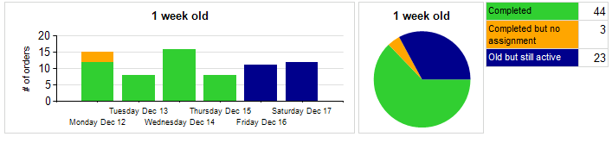

Work order status, which signifies whether an order is complete, is shown via color. ORANGE, DARK BLUE, AND DARK GREY orders are incomplete. They should be corrected. To find incomplete orders, you can:

* Page through the <http://machete/workorder> -> Details Tab. The orders are color-coded
* Review “Incomplete Work Orders (List)” report on the <http://machete/reports> -> Workers Tab.

Order Status Legend:

|  |  |  |
| --- | --- | --- |
| GREEN | Completed & Assigned | Green is good! The order is marked as completed, and a worker is assigned to the work order. |
| YELLOW | Completed & Assigned | Yellow is almost as good as Green. The order is completed, and a worker assigned, but the assignment is not associated with a Worker Signin. This happens with multiple dispatches. |
| ORANGE | Completed & NOT Assigned | The order is marked as completed, but the dispatcher did not assign a worker to the order. |
| RED | Cancelled | The Employer cancelled the order. |
| BLUE | Active | The Order is active. |
| DARK BLUE | OLD but still Active | The Order is in the past; it should be cancelled or completed. |
| GREY | Pending | The order is not yet ready to be marked active. Pending orders are not eligible for dispatch. |
| DARK GREY | OLD but still Active | The order is in the past; it should be cancelled or completed. |

## Monthly work order status (Pie Charts)

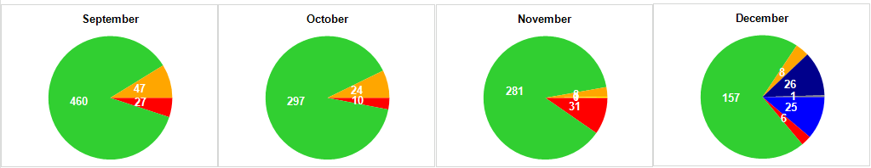

The monthly pie chart shows the same work order status information, but for an entire year, by month. The monthly view shows orders from previous months that are still incomplete.

* The monthly pie chart is the best overview of the quality of the Machete work order data
* Orange, dark blue, and grey orders should be corrected

### Manager Questions

1. Why are there incomplete records? (Orange, dark blue, dark grey)
2. Can anyone find the paper record to determine the worker, and enter the information in Machete?

## Worker Signins with Expired Memberships (List)

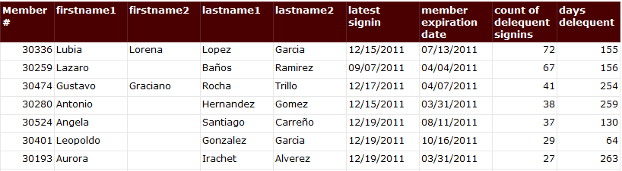

Part of Casa Latina’s mission is to educate workers, and participation in the education program is a required part of membership. For Machete to determine whether a worker is eligible, and provide this information to dispatchers in real time, the worker records in Machete must be up to date.

A manager should review the “Worker Signins with Expired Memberships” report once a month.

### Manager Questions

1. Are the expiration dates correct in Machete?
2. If the expiration date is correct, and the worker has not renewed his or her membership, why not?

# Operations Tasks (Dispatchers – Juan and Gabriel)

Machete records work orders, assigns workers to those work orders, and captures the infomration into a database. Once the information is in the database, the task of analyzing it is much easier than when the information is record on paper slips. However, the review of operations is still an on-going maintenance task.

In order for Machete reports to be reliable, every effort should be made to keep Machete data current. The following list is a work in progress, but reflects the known tasks that must happen for Machete work order data to be reliable.

# Daily operations tasks

## Review Machete Work Order Summary

Click on the WorkOrders Menu link (**Green #1**), then Click on the Summary Tab (**Green #2**)

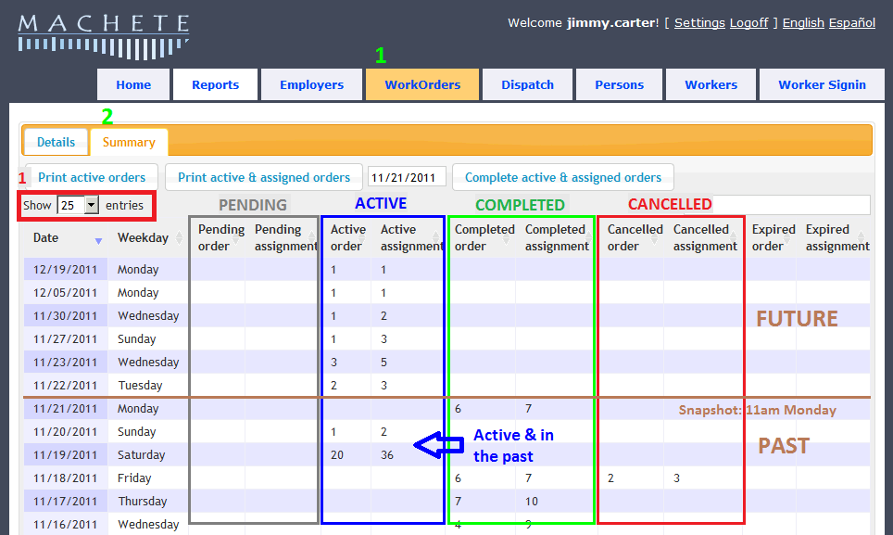

The Work Orders Summary page shows the volume and status of recent orders. There are 5 groups of columns that show order status. Each group has 2 columns: Work Order Count and Assignment Count. (highlighted color boxes are for illustration only).

* The display can show up to 100 entries (**Red #1, above**). This allows for easy review of the past 3 months.
* Notice the 5 groups: Pending, Active, Completed, Cancelled, and Expired. These are the possible status settings for a work order. The status reflects where the work order is in the dispatch process.
  + PENDING: New orders; orders from automated sources; not ready to be dispatched
  + ACTIVE: Orders that are ready to be dispatched
  + COMPLETED: Orders marked as completed
  + CANCELLED: Orders cancelled by the employer
* The Order Count is different from the Assignment Count because an Order may need more than one worker. An assignment reflects the number of workers needed.
* As the current date progresses, Work Order counts should shift from Active to Completed or Cancelled. Assignments will shift with the work orders.
* Pending and Active orders in the past are incomplete and should be corrected.

### Dispatcher questions

#### Were all work orders assigned a worker and completed? Or alternatively, was the work order cancelled?

#### Are there any work orders in the past that are still active or pending?

The best time to complete work orders is on the same day that they were assigned and dispatched. If they cannot be completed the same day, they should be completed as soon as possible.

## Review Machete Work Orders by color

Click on the WorkOrders Menu link (**Red #1**), Check on the Details Tab (**Red #2**)Filter work orders by their status using the filter buttons (**Red #3)**

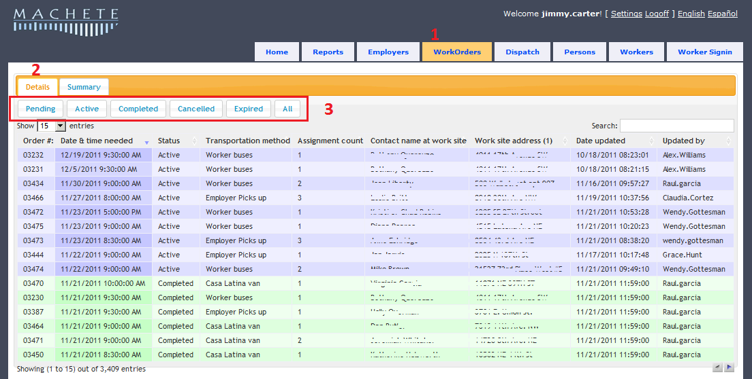

The Details tab shows all work orders is chronological order, and allows the user to edit the work order by double-clicking it. The color of the work order row reflects the status of the work order.

|  |  |  |
| --- | --- | --- |
| GREEN | Completed & Assigned | Green is good! The order is marked as completed, and a worker is assigned to the work order. |
| YELLOW | Completed & Assigned | Yellow is almost as good as Green. The order is completed, and a worker assigned, but the assignment is not associated with a Worker Signin. This happens with multiple dispatches. |
| ORANGE | Completed & NOT Assigned | The order is marked as completed, but the dispatcher did not assign a worker to the order. |
| RED | Cancelled | The Employer cancelled the order. |
| BLUE | Active | The Order is active. |
| DARK BLUE | OLD but still Active | The Order is in the past; it should be cancelled or completed. |
| GREY | Pending | The order is not yet ready to be marked active. Pending orders are not eligible for dispatch. |
| DARK GREY | OLD but still Active | The order is in the past; it should be cancelled or completed. |

## A bigger example

The image below is of the Work Order Detail stab with the Show Entries drop-down set to 100 entries. It shows many green completed orders, which is the goal for most orders. 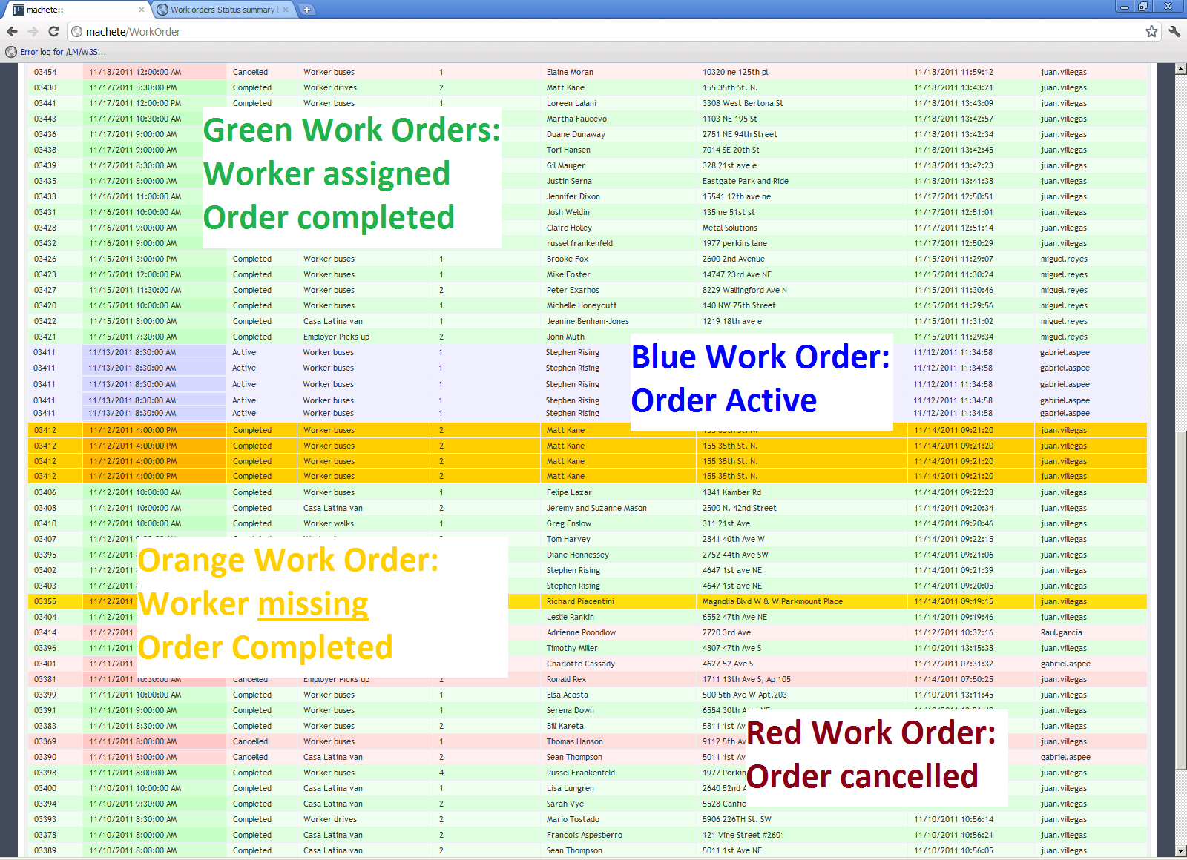

The block of Blue orders means that one day, someone probably forgot to assign workers to work orders in Machete, and needs to assign them and close the orders. Orders need to be completed so that there is a record of who worked for the Employer. Also, only completed orders show up in some reports.

Grey orders mean the order is still pending. If the order is grey and in the past, it should be cancelled.

The Orange orders means that the order was marked as completed without a worker being assigned. This is an incomplete order. There will be no record of who worked for the Employer, survery data will not be meaningful, and some reports will be less accurate.

### Dispatcher Questions



#### Can the worker for the orange work order be found? If so, update Machete

#### Is the blue or grey order in the past? Do we have a paper record? Can we update Machete?

# Weekly operations tasks

Aside from the Work Order Summary and Details tab, all reports come from the Microsoft Report Server (SSRS). The Machete Reports page links to the reports developed for Machete; additionally, anyone can create their own reports using the server, but they will not be visible from Machete.

## Review Monthly Work Order Statuses (pie charts)

The Machete Reports page is a simple portal to the reports available from the Report Server (SSRS).

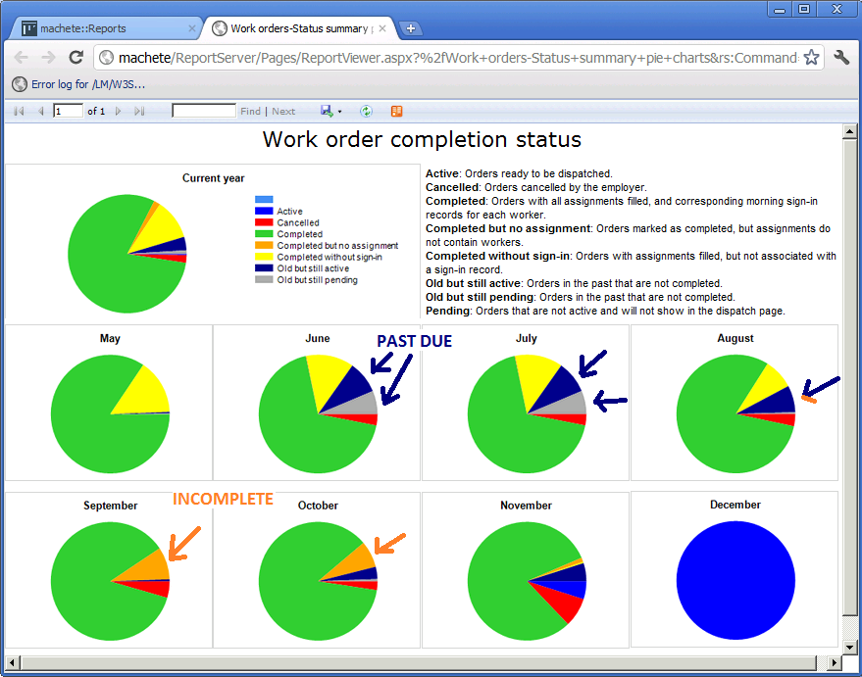

* The goal is to minimize or remove all the dark blue, grey, and orange orders.
* Some yellow and red are inevitable.

### Dispatcher Questions



#### Are the percentages of incomplete work orders shrinking?

* + - Orange work orders are completed, but missing a worker
      * Without a worker assigned, reporting will be less accurate
      * Without a worker assigned, there is no searchable record of who was dispatched

#### Are there work orders in the past that are not completed or cancelled?

* + - Blue work orders are active. Their date is either the current date or a future date
    - Dark blue are active but in the past; they should be completed or cancelled
    - Dark grey are pending but in the past; they should be completed or cancelled

## Review Incomplete Work Orders (List)

The Work Order page and the Details & Summary Tabs make is easy to see the status of recent work orders. However, work orders can quickly disappear as new orders are added. To find incomplete work orders that farther in the past, use the Incomplete Work Orders report.

The rows of the Incomplete Work Orders report the total number (Red #1) of work orders that are incomplete or past due.

* The second column shows how many of the incomplete do have workers assigned to the work order

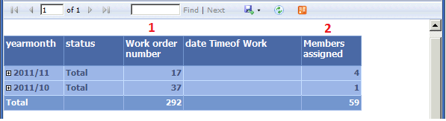

* The difference between the work order number and the members assigned is the number of work orders that are missing worker assignments
* The goal is to reduce the numbers in both columns by filling all the work orders with workers, then completing the work orders

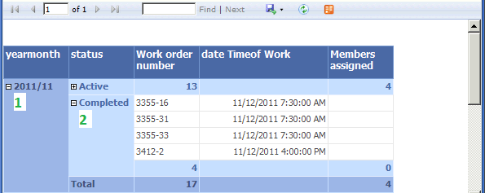

The Incomplete Work Orders report will allow the user to expand monthly totals to show sub-totals by the statuses of the incomplete orders. In the example above, for November 2011 (**Green #1**), there are 17 incomplete work orders. Of those orders, 13 have their status set to Active and 4 are marked as Completed.

The user can further expand the Status record and show the individual work orders and their Order Number, so they can be quickly accessed in Machete. The Date & Time of the work order is also visible.

The Work Order number has two parts [#####-##]:

* the Work Order Number
  + hyphon [-]
* the Assignment Number

The Assignment number reflects which assignment in the work order is missing information

### Dispatcher Questions



#### Can we find which worker was assigned for a given incomplete work order?

#### Are the total numbers of incomplete work orders shrinking over time?

#### What can be done so that there are no incomplete orders in the coming month?

## Review Workers-Signins Past Membership Expiration

Machete is designed to track a membership date for each worker to track whether workers meet the organization’s objectives for membership. A text message that a worker is expired flashes when the worker registers every morning. However, if too many workers are expired, the message will be ignored.

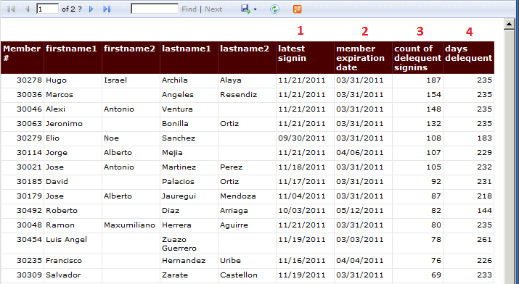

* Review the Signins Past Membership Expiration list to identify which workers need to renew their membership
* The report shows
  + the latest date of signin by the worker (**Red #1**)
  + the date of membership expiration (**Red #2**)
  + the number of signins since expiration (**Red #3**)
  + the number of days since expiration and the latest signin (**Red #4**)

### Dispatcher Questions



#### Are the worker records current?

#### Do they reflect all renewed memberships?